**Flu shots have / have no side effects**

# Safety, Reactogenicity, and Health-Related Quality of Life After Trivalent Adjuvanted vs Trivalent High-Dose Inactivated Influenza Vaccines in Older Adults: A Randomized Clinical Trial

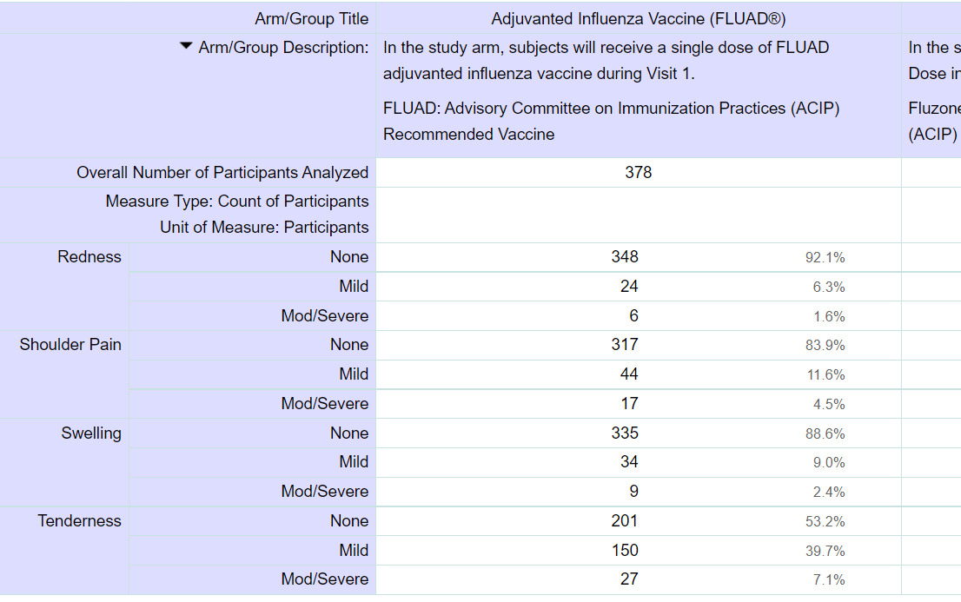

<https://clinicaltrials.gov/ct2/show/results/NCT03183908>

# A phase II study of an investigational tetravalent influenza vaccine formulation combining MF59®: adjuvanted, pre-pandemic, A/H5N1 vaccine and trivalent seasonal influenza vaccine in healthy adults

# There is a list of side effects which can be caused by flu shots.

# 

<https://clinicaltrials.gov/ct2/show/results/NCT00620815>

# Safety and immunogenicity of inactivated monovalent influenza A/H1N1 vaccine candidate manufactured in Vietnam

# There is a small list of side effects:

# 

<https://clinicaltrials.gov/ct2/show/results/NCT01507779>

# A randomized, controlled non-inferiority trial comparing A(H1N1)pmd09 vaccine antigen, with and without AS03 adjuvant system, co-administered or sequentially administered with an inactivated trivalent seasonal influenza vaccine

# There is small list with reactions:

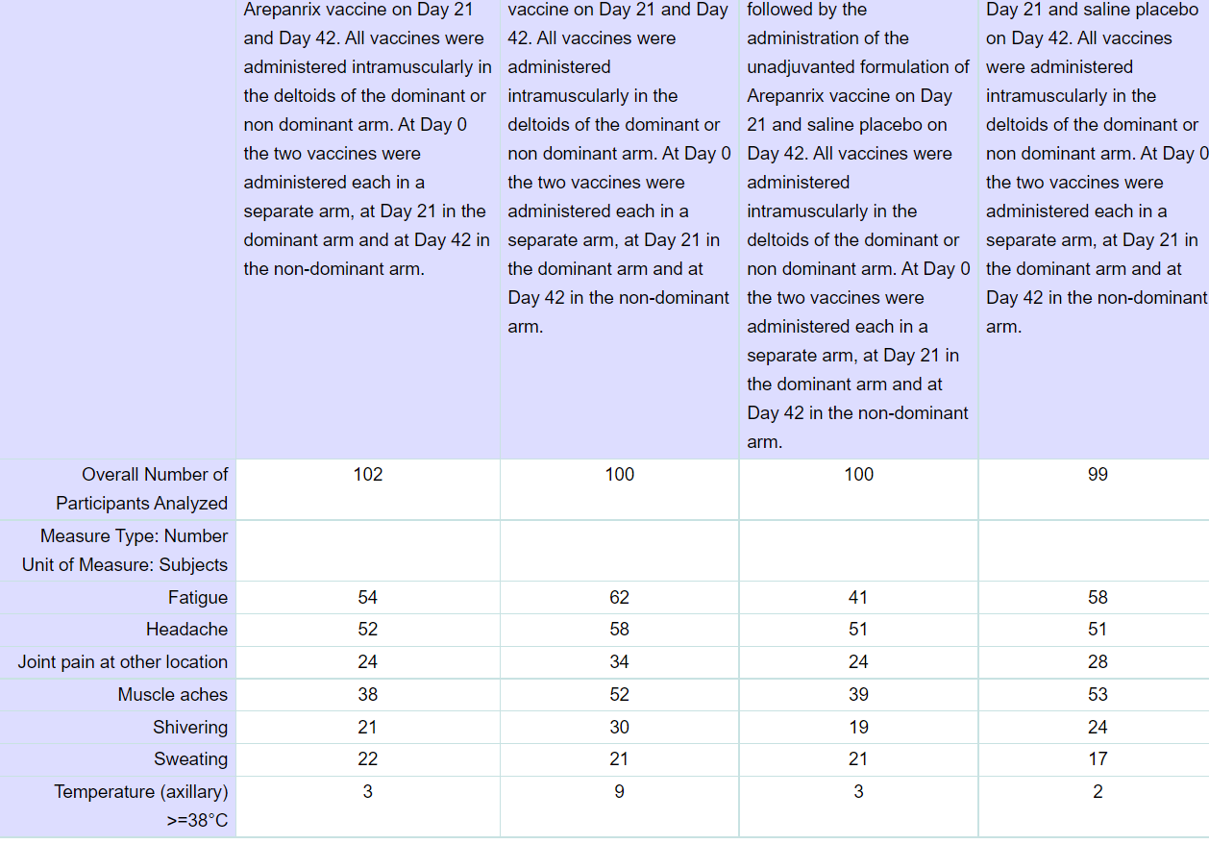

<https://clinicaltrials.gov/ct2/show/results/NCT00985673>

**Usefulness or not usefulness drinking coffee**

# Absorption, Pharmacokinetics, and Urinary Excretion of Pyridines After Consumption of Coffee and Cocoa-Based Products Containing Coffee in a Repeated Dose, Crossover Human Intervention Study

<https://pubmed.ncbi.nlm.nih.gov/32776430/>

# Effect of green coffee extract supplementation on serum adiponectin concentration and lipid profile in patients with non-alcoholic fatty liver disease: A randomized, controlled trial

# Green coffee extract (GCE) supplementation improved serum lipid profile and BMI in individuals with NAFLD. GCE may be useful in controlling NAFLD risk factors.

<https://pubmed.ncbi.nlm.nih.gov/32147076/>

# The Acute Effects of Caffeinated Black Coffee on Cognition and Mood in Healthy Young and Older Adults

There are some notes in abstract about coffee harmful effects.

<https://pubmed.ncbi.nlm.nih.gov/30274327/>

**“Grippol Plus” research results**

1. Children between 3-35 months old

Местные реакции (боль, покраснение, припухлость) после первой и второй вакцинации варьируется в диапазоне: 3.1% – 7.4%

Общие реакции (головная боль, недомогание, нарушение аппетита, нарушение сна, потливость, насморк, кашель) варьируется в диапазоне 1.5% - 14.5%. Все они были кратковременными, не требовали медикаментозной коррекции.

1. Older people 60+ years old

Местные реакции (боль, покраснение, зуд, уплотнение в месте введения) зарегистрированы у 16,6% вакцинированных. Проходили в течение 3 дней самостоятельно.

Общие реакции отмечали у 22% вакцинированных. Наиболее частая – головная боль (14%-16%), боль в суставах (2.5%–3.4%), субфебрильная температура (до 37.5) – 2.5%. Все реакции были кратковременными и проходили самостоятельно.

<https://grippol.ru/grippol-plus/evidence/>

I tried to find out clinical trials of this vaccine, it’s the only result (only one link).